Explain state in react to 4-year-old kid.

What is virtual dom in react? How it is efficient than real dom?

Diffing algorithm?

Concept of Batching in react?

What is Lifting Up in react?

Some cases when lifting-up is best solution?

What is use of key in map? Is using index as key is best practice? and why?

What if we use product name + index as key?

Implement 1 circle and 1 square

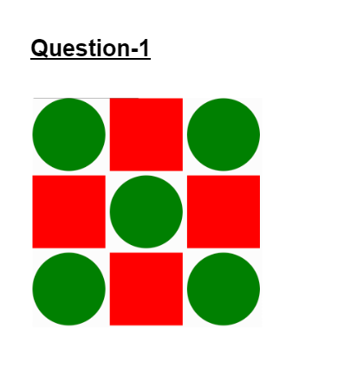

Implementing this using html css

How would you implement this using react?

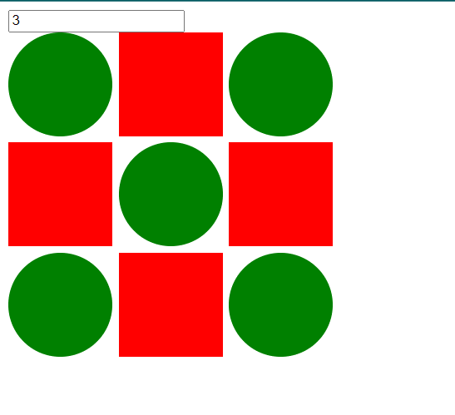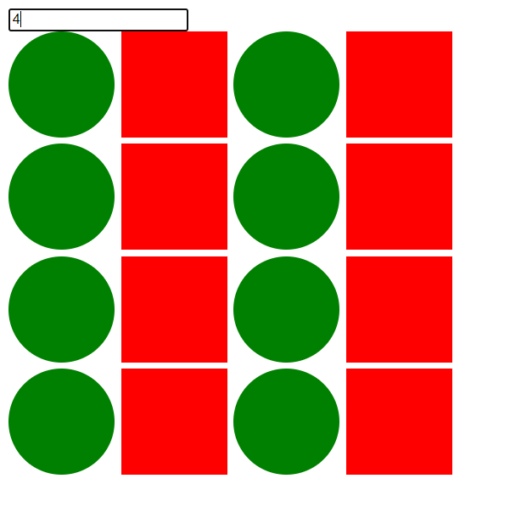

function isSquareorCircle(row, col, n) {

// returns 0 or 1 0 - square & 1 - circle

}

Output based:

**1.**

console.log('start');

setTimeout(() => {

console.log('setTimeout');

}, 0);

Promise.resolve().then(() => {

console.log('promise');

});

console.log('end');

**2.**

for (var i = 0; i < 5; i++) {

setTimeout(() => {

console.log(i++);

}, 300);

}

What if var changed to let.

Projects, shown 2 projects.